

SIMATS ENGINEERING

Saveetha Institute of Medical and Technical Sciences
Chennai- 602105

Student Name: Challa Priyadarshini
Reg. No.:192321421
Course Code: CSA0927 Slot: D
Course Name: Programming in Java
Course Faculty: Dr. Pushpa Latha S
Project Title: Implementation of a Java-Based Virtual Classroom System
Module Photographs: (3 photographs –Module Photo, Individual student contribution module work in the project and presentation image)
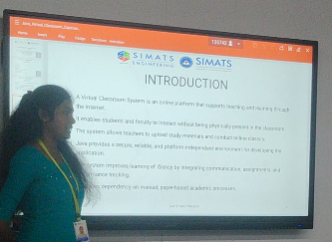
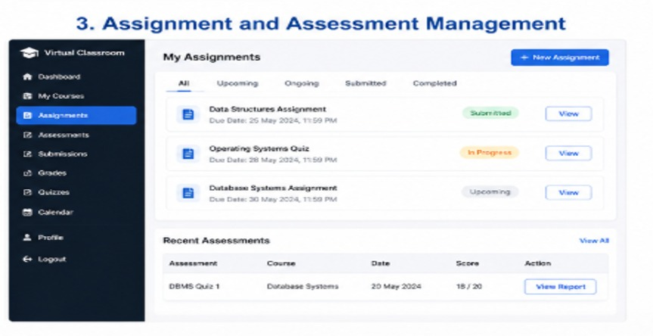
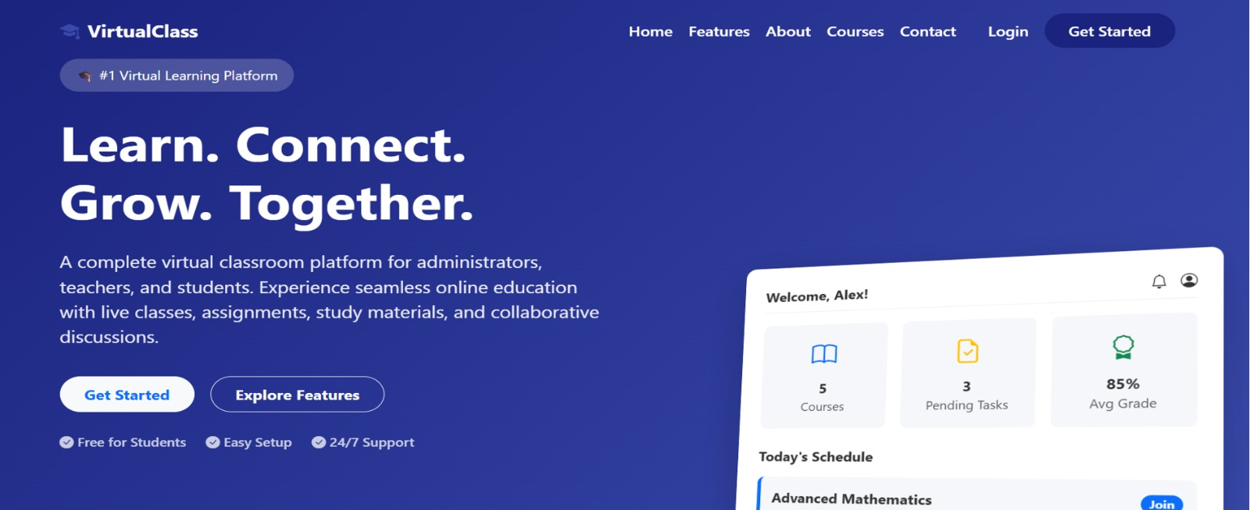

Project Description:

The Java-Based Virtual Classroom System provides an organized platform for online education. The Assignment and Assessment Module manages assignments, quizzes, tests, and evaluations.
Teachers can create and publish assignments for specific courses or subjects. Students can view assignment details and submit their work online. The module supports deadlines and submission tracking.
Teachers can evaluate submissions and provide marks or grades. Online quizzes and assessments can be conducted to measure student performance. The system can automatically calculate scores for objective questions. Students can view their marks and receive feedback from teachers. This module helps monitor academic progress and improves the overall learning process.

Student Signature Guide Signature

